Contents
2. PCB Design 2

PCB Design

D-SUB connector to PCB board
24/08/2026
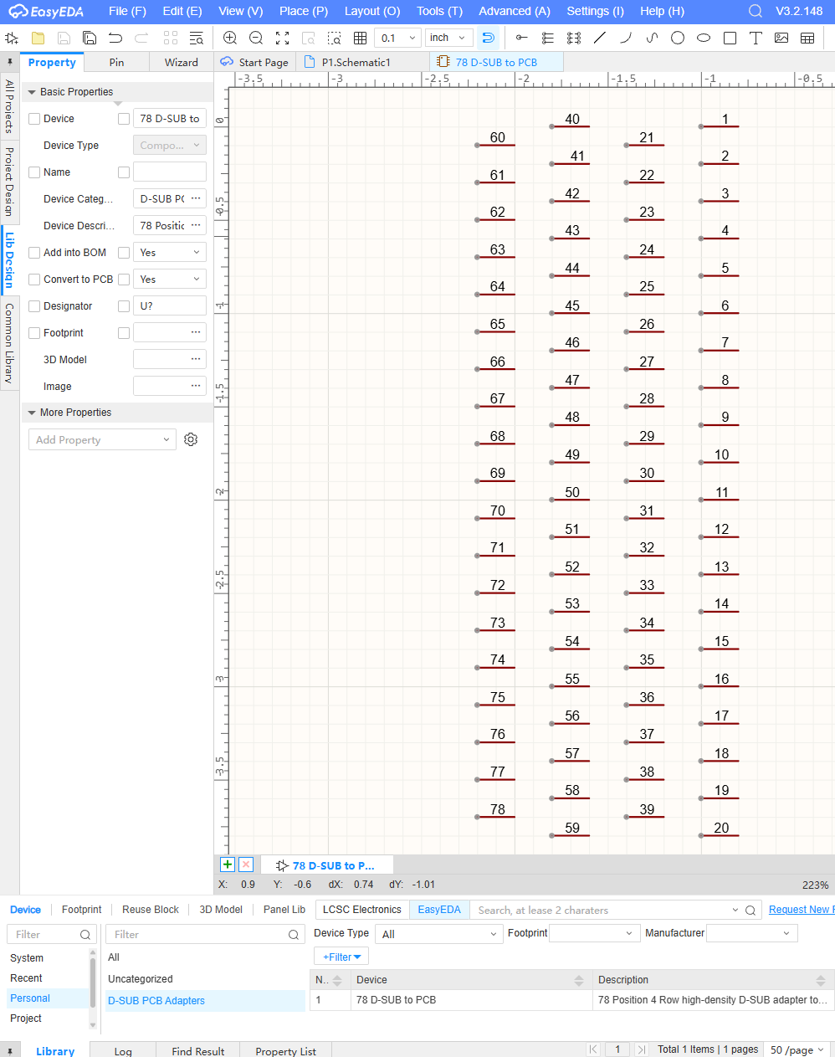
2.1. Figure 1 – First EasyEDA project schematic with a custom component symbol
The custom component symbol pre-placed in the first schematic page consist of 78 pins. These pins will be used as plated-through hole slot connectors once the associated footprint is developed [1].

Reminder: Save this as first document to git

References

[1] | “Plated-through slots,” [Online]. Available: www.pcbway.com/pcb_prototype/Plated_through_slots.html.

